POLICE STATION MANAGEMENT SYSTEM
ABSTRACT
The police management application can help in storing the records related to the criminals, cases, complaint record, case history and so on. This can allow a person to enter or delete the records if necessary. All these records can be maintained in a single database. Security is maintained so as to ensure that only the authorized users will have access to the system. This application will be one of the useful projects that the police can rely on. This application can help in getting the information of the criminals of many years back. It can also help in minimizing most of the work of the police.
SYSTEM SPECIFICATION
HARDWARE SPECFICATION:
- Processor : P 4 700 GHz.
- RAM : 4 GB RAM
- Hard Disk Drive : 180 GB

SOFTWARE SPECIFICATION:

- Operating System : Windows 7/8/10
- Front End : JAVA
- Back End : SQL
EXISTING SYSTEM
In the existing police station management system, most of the operations are done manually like send complaints, taking actions against crimes, view status etc. This system needs more man power to track the records of crimes. Retrieving old crime records is very time consuming. In the current system all work is done on papers so it is very difficult to secure crime reports data. Error detection in the previous entries made and data cross verification is another important function. These are done manually, and it would take time. the existing system has more workload for the authorized person, but in the case proposed System, the user can register in our site and send the crime report and complaint about a particular city or person.
Disadvantages
- The existing system doesn’t have system security.
- The existing system is time consuming and not very user friendly.
- So, with the existing system if anybody wants to complaint against crimes, he must do it through the police.
PROPOSED SYSTEM
The proposed crime records management system can overcome all the limitations of the existing system. The system provides proper security and reduces the manual work. The efficiency of the police function and the effectiveness with which it tackles crime depend on what quality of information it can derive from its existing records and how fast it can have access to it. The existing system has several disadvantages and many more difficulties to work well. It is proposed to centralize Information Management in Crime for the purposes of fast and efficient sharing of critical information across all Police Stations across the territory.
Advantages
- The proposed system helps the user to work user friendly and he can easily do his jobs without time lagging.
- The proposed system tries to eliminate or reduce these difficulties up to some extent
- Easy to manage the software

MODULES:
- Police stations registration module:
This module maintains the information about all the police stations that are registered as per the jurisdiction of the system. For the registration part each station enters their details like station name, address, phone no, station in charge etc. and get a User Id from the Software. It also gets integrated with the employees who are working in these stations along with their designation. Once the prospective station registers with the software they can avail the existing records.

- Citizen Registration module
This module first should contain the collect the information by manually, they citizen themselves gave username and password using this to entered in to the login application. Once they entered into the application, they will raise the complaint.

- Complaint Registration
Citizens are manually raising the complaint to the respective police station. Once they will raise the request a police station admin can get the notification. They can take an action to the respective complaint.

- View Complaints
The admin can able to view the pending cases in this module. it has been managing by the system admin he/she can allocate the case to the respective police then they can follow the request.
- Complaints history
The citizens are checking their cases history in this module, whether which is closed or not. Based on these they can view the complaint history. Police also monitoring this module can helps to find the pending cases.

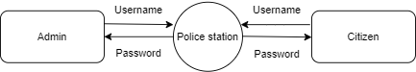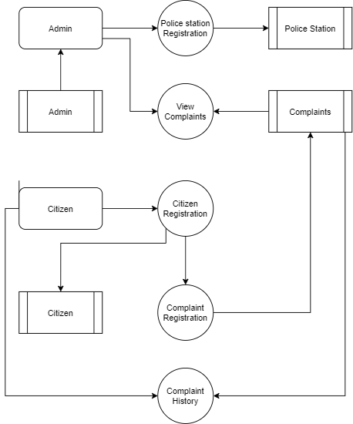

TABLE NAME: ADMIN

FIELD | DATA TYPE | SIZE | CONSTRAINT
Admin id | Int | 10 | Primary key
Username | Varchar | 20 | Not null
password | Varchar | 20 | Not null

TABLE NAME: POLICE STATION

FIELD | DATA TYPE | SIZE | CONSTRAINT
Station id | Int | 10 | Primary key
Station name | Varchar | 20 | Not null
Address 1 | Varchar | 30 | Not null
Address 2 | Varchar | 30 | Not null
City | Varchar | 15 | Not null
State | Varchar | 15 | Not null
Pincode | Int | 6 | Not null
Landline number | int | 10 | Not null

TABLE NAME: CITIZEN

FIELD | DATA TYPE | SIZE | CONSTRAINT
citizen id | Int | 10 | Primary key
Firstname | Varchar | 20 | Not null
Lastname | Varchar | 20 | Not null
Mobile | Int | 10 | Not null
Address 1 | Varchar | 30 | Not null
Address 2 | Varchar | 30 | Not null
Areaname | Varchar | 15 | Not null
City | Varchar | 15 | Not null
State | Varchar | 16 | Not null
Pincode | Varchar | 6 | Not null

TABLE NAME : COMPLAINT

FIELD | DATA TYPE | SIZE | CONSTRAINT
Complaint id | Int | 10 | Primary key
Citizen id | Int | 10 | Foreign key
Station id | Int | 10 | Foreign key
Complaint person | Varchar | 20 | Not null
Complaint issue | Varchar | 30 | Not null
Current address | Varchar | 30 | Not null

